**Android Controlled Automated WASTE Management System for Physically Disable people**

Imtiaz Ahmed Chowdhury1, Anindo Dey2, Partho Das3 and Bijan Paul4

1, 2, 3 Student, University of Liberal Arts Bangladesh, Dhaka, Bangladesh

4Senior Lecturer, University of Liberal Arts Bangladesh, , Dhaka, Bangladesh

1[imtiaz.ahmed1.cse@ulab.edu.bd](mailto:imtiaz.ahmed1.cse@ulab.edu.bd), [2partho.mazumder.cse@ulab.edu.bd](mailto:2partho.mazumder.cse@ulab.edu.bd), 3anindo.dey.cse@ulab.edu.bd & [4bijan.paul@ulab.edu.bd](mailto:4bijan.paul@ulab.edu.bd)

**Abstract.** This paper shows a cost-effective structure of android controlled automated smart waste container for small scale cases. This framework depends on Arduino Uno board, an ultrasonic sensor, servo motor, L298N motor driver and Bluetooth to monitor the waste container. It is powered by a lithium battery power bank supported. Also, the framework constrained by Android application for movement and Ultrasonic sensor which identify the items. We implemented a smart waste management system, especially for physically disabled people. At long last, the framework is executed effectively with an adequate by and large expense for the proposed application. The system execution was discovered attractive according to the obtained test results.

**Keywords:** Android, Bluetooth, Arduino, Robotic Car, Ultrasonic Sensor, Servo Motor, Motor Driver

1. Introduction

This project basically designed which people those are physically disabled. Most of the case the disable people face some problem like they want to clean their environment, but they're not enabled to do that because of their physical issue. This project helps them to clean their environment and this automated dustbin controlled by Android can much easy their everyday life. We are presently living in the 21st century. Presently, the advanced mobile phone has transformed into the most fundamental thing in our regular daily existence. Android application-based smartphone is transforming into each time even more predominant and outfitted with a couple of embellishments that are useful for Robots. This project portrays how to control an automated smart dustbin using mobile through Bluetooth communication, some features about Bluetooth technology, components of the mobile and robot. We determined basic answers of a structure to building automated smart dustbin with very low cost but with high computation and detecting capacities given by the smartphone that is utilized as a control device. This paper is organized as follows: section 2 describes a literature survey, section 3 describes the methodology, section 4 demostrate result and discussion, and section 5 describes future work and conclusion.

1. Literature Survey

This article presents Smart Dustbin Monitoring System using LAN Server and Arduino [5]. And the most current related work is done by Fady Samann [6] on The Design and Implementation of Smart Trash Bin. Another work on Automatic Intelligence Car Robot by Rajesh Singh Shekhawat and Shekhawat Amit Sain and Gaurav Bhardwaj [7] it can sense the environment and decide the navigation path without any human input. But those existing paperwork to solve the environmental problem and ability to sense the environment and decide the navigation path without any human input. Now in this paper, we are working to combine two existing papers and add some of our ideas of a smart dustbin and an android application-controlled car which help the people who are physically disabled.

1. Methodology

In the present paper, the design of robotic dustbin uses engineering method. In sequence, the method is the identification of the needs required. Then these needs are analyzed to get specific components. These components are later integrated to get the desired output. The basic circuit diagram and block diagram is as shown in figure 1 and figure 2.

**3.1 Operation of Robot**

The operation of the robot can be classified into two main categories. They are motion control of the robot, open up and collect garbage and shut its lid using the sensor.

**3.1.1 Locomotion of the Robot**

The robotic dustbin can travel in the wanting path by using a combination of motors, drivers, and Bluetooth driver connected to the Arduino. This system consists of four geared motors of 30rpm each, motor drivers and Bluetooth driver. The android application commands act as input to the Arduino. The motors are connected to the output of the Arduino through the drivers. The motors are made to move and rotate based on the Android application instructions in the Arduino.

**3.1.2 Procedure of Garbage Collection**

The robotic dustbin’s lid open up by servo motor via an ultrasonic sensor when an object or human body parts come near to the dustbin then collects the garbage and after some time (pre-programmed time) the lid of dustbin automatically shut.

**3.2 Circuit Diagram**

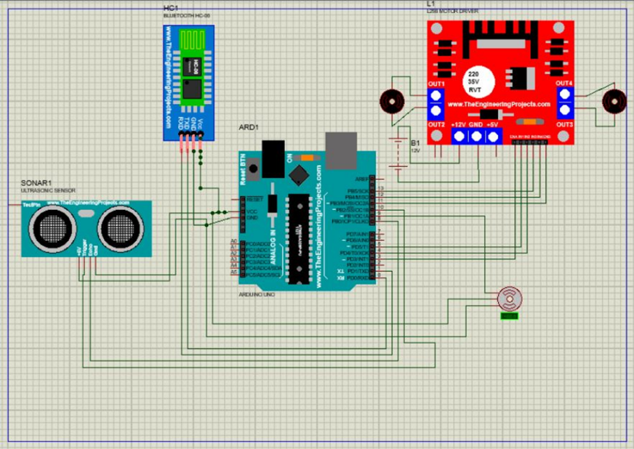

**Fig. 1*.*** Circuit Diagram of the system

**3.3 Block diagram**

**Ultrasonic Sensor (Object Sense)**

**ServoMotor(Open/Shut)**

**Vehicle**

**Motor Controller**

**Bluetooth**

**Collection Mechanism**

**Processor**

**Application**

**Fig. 2.** Block Diagram of the system

**3.4 System Integration**

System incorporation is characterized by our system as the way toward uniting the part subsystem into one system.

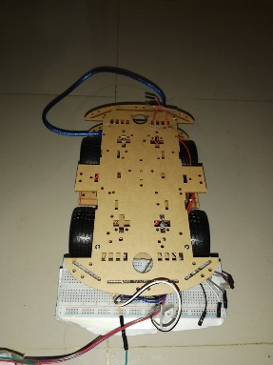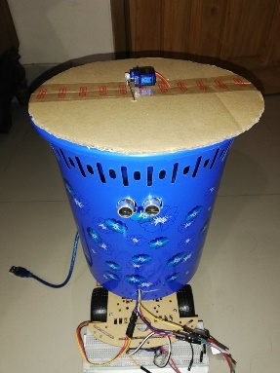

**Fig. 3.** Automated Car Smart Dustbin

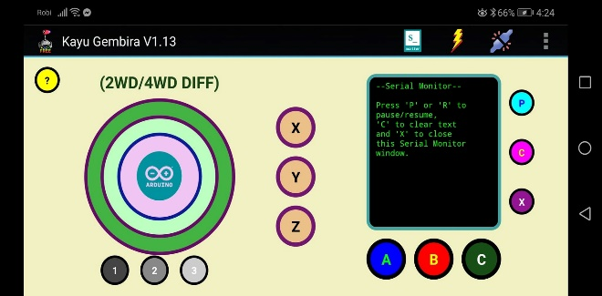

**Fig. 4.** Android Application (KayuGemdira)

**3.5 Pseudo Code**

Include Servo library

set tringpin = 10

set echopin = 8

Distance centimeter

Boolean if true it will turn on

Boolean if false it will be off

servo motor on digital pin (9)

tring pin show output

echo pin show input

loop (iftring pin low there eill be delay .2 sec

if tring pin high the delay will be 10 microseceond

centimeter duration 58.9 sec

if {

if servo meter distance is less 30 centimeter

then the it will turn the center position 90 degree

and it will wait 3 sec. then will be go it previous position

}

else {

if servo meter distance is 0, then it will be no change

}

1. Result and discussion

For building up this project, we have accomplished the accompanying achievements. The android controlled robotic dustbin has been made effectively and testing has been accomplished for all the realized cases with respect to the utilization of venture.

We are successfully have done the robotic dustbin. An application from play store which is Bluetooth control has been install to run the robotic dustbin. It controls the wheels and the ultrasonic sensor is attach with Arduino Uno. It will detect any object in front of it and the lid will be automatically open by the servo meter. The Dc motors are connected with L298N motor driver, it controls the Dc motors and the L298 motor driver is connected with Arduino Uno and 9v battery. The Bluetooth

driver and the ultra-sonic sensor don’t work together with the power supply with Arduino Uno control the ultra-sonic sensor and 9v battery supply the power to run the motor driver.

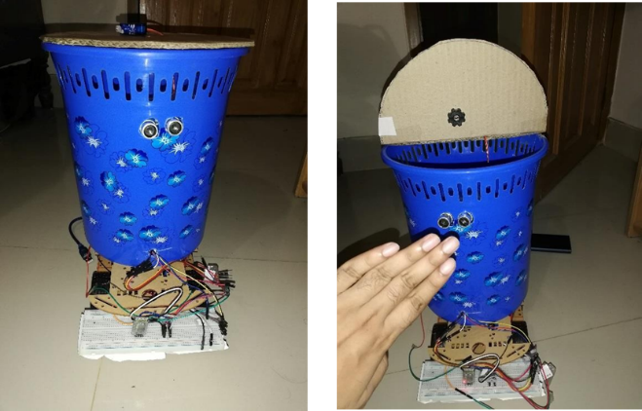

**Fig. 5.** A prototype of the system

**5. Future Work and Conclusion**

Most of the past work on this subject focused on solving waste management, automation and navigation path without any human input. Now we have integrated smart dustbin with an automated car which can navigate the path with the help of an android device. Limitation of resources we cannot integrate voice command (Artificial intelligence) in this project. In future, we will integrate voice command in our project.

The project proposes a cost-effective and user-friendly Android Controlled Dust Management System using Bluetooth and Arduino. The significant advantage of the project is to help people those are physically disable. Whereas this system is user-friendly we can use especially in hospital for the patient who is unable to move and this system also can be used in home or office for easing the daily life.

**References**

1. Gopal V. M. &Roshani A. N. (2018, July). Smart Garbage Monitoring System. International Journal of Trend in Scientific Research and Development
2. Maity A. & Bhattacharya A. (2017, November). Android Application Based Bluetooth Controlled Robotic Car. International Journal of Intelligent Information Systems. Vol. 6, No. 5, 2017, pp. 62-66.
3. Roy S. &Rapden T. (2016, February). Arduino Based Bluetooth Controlled Robot. International Journal of Engineering Trends and Technology (IJETT). Volume 32. Number 5.
4. Sharma S. & Singh, S. (2018, May). Smart Dustbin Management System. International Journal of Engineering Sciences & Research Technology.
5. Selvaraj, K. & Chakrapani, A. (2017, April). Smart Dustbin Monitoring System using LAN Server and Arduino. International Journal of Advances in Computer and Electronics Engineering. Vol: 02. pp. 20 – 23.
6. Samann, F (2017, January). The Design and Implementation of Smart Trash Bin. Academic Journal of Nawroz University (AJNU). Volume 6, No 3.
7. Shekhawat, R. S. &Sain, S.A & Bhardwaj, G. (2016, April). Automatic Intelligence Car Robot (IJSTE). International Journal of Sciences Technology and engineering. Vol 2.